**nRF24L01+ RF Module**

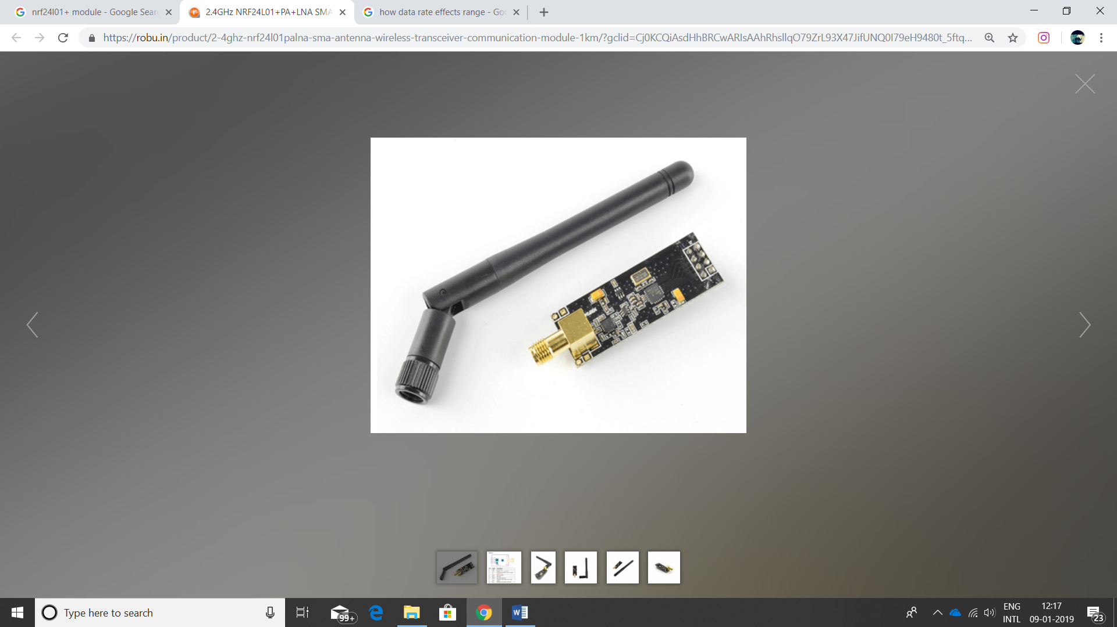

1. Voltage: 3-3.6V (recommended 3.3V) V.
2. Power-down mode current: 4.2uA.
3. Operating Range: 1Km
4. Antenna Gain (peak): 2Dbi.
5. 2MB rate (Open area): 520m.
6. 1MB rate (Open area): 750m.
7. 250Kb rate (Open area): 1100m.
8. It uses 2.4GHz global open ISM band, with license free.
9. SPI interface facilitates the communication with MCU I/O port.

The nrf24l01+ works between 2.400 – 2.4835 GHz. Multiple channels options to overcome interference. It works on Enhanced ShockBurstTM protocol which gives a very two-way comm btw two (and up to 6) modules.

In the rover we need it for controlling traversing and robotic arm.

The nRF24L01+ variant can communicate with other nRF Modules but only on 1Mbps and 2Mbps air data rate. Though it supports 250Kbps the nrf24L01 does not.

Due to appropriate price, we feel it proper for the prototype.

Cost=Rs 250

**Link:**

<https://robu.in/product/2-4ghz-nrf24l01palna-sma-antenna-wireless-transceiver-communication-module-1km/?gclid=Cj0KCQiAsdHhBRCwARIsAAhRhsllqO79ZrL93X47JifUNQ0I79eH9480t_5ftqXX4uclyOy6nmDiyfsaAmaiEALw_wcB>

**DataSheet:**

https://www.sparkfun.com/datasheets/Components/SMD/nRF24L01Pluss_Preliminary_Product_Specification_v1_0.pdf